Development of a Range of Modified Multifunctional Residual Current Systems and Their Industrial Implementation

О.К. Nikolsky, Т.М. Khalina
Russia, Barnaul, AltSTU

The developments of the AltSTU have been reviewed in the area of creating a new technology for preventing technogenic hazards based on the residual current devices. The residual current devices are intended for protecting people from electric shock in case of contact with conductive parts of the electric appliances and shall facilitate reduction of fire risks caused by a prolonged flow of leakage currents and fault currents resulting from them. The results of creating different modifications of protective trip circuits and their industrial use are provided.

The transition of Russia to power supply systems with separating working and protective neutral conductors (TN-C-S and TN-S) created the technical prerequisites for the massive use of residual current devices. The high electrical protective efficiency of the RCDs, due to the improved characteristics in terms of speed and sensitivity, compared to conventional means of electrical protection, imposes increased requirements for noise immunity to exclude false alarms and interruptions in the power supply to consumers, which led to the need for experimental studies of the parameters of power grids [1-3]. For this purpose, AltSTU created special measuring equipment, with the help of which the natural leakage currents of internal electrical networks and electrical receivers, short circuit currents, touch voltages were determined, the influence of external factors (rainfall, atmospheric and switching overvoltages, etc.) on the operation of RCDs was analyzed. ... In addition, studies were carried out on the influence of higher harmonics of the load current of protected lines, as well as currents induced by high-voltage power lines passing through rural areas [4, 5]. The results of the studies performed made the basis for the formation of a series of modified RCDs and the preparation of a design and technological base for their production in three main areas [6, 7].
1. Creation of multifunctional electronic protective devices.
2. Creation of protective devices for individual use of electronic design.
3. Creation of hybrid electrical protections with an electromechanical converter.

1. Multifunctional device for electrical and fire safety shutdown of increased power with overvoltage protection UZK-01 is intended for:
- protecting people and animals from electric shock;
- preventing fires and ignitions caused by leak currents, power surges, and short circuits;
- isolating electric receivers in case of overvoltages;
- measurement and alarm in case a setup value of residual current has been exceeded.
UZK-01 is a three-pole, four-wire autonomous residual current device controlled by a differential current, with discrete regulation of the magnitude of the tripping currents, with built-in protection against overcurrents and overvoltages, operating in alternating current electrical systems with a grounded neutral (Figure 1).
UZK-01 differs in the form of the differential current into types: AC - responsive to sinusoidal alternating current; A - responsive to sinusoidal alternating current and pulsating direct current. To ensure the possibility of serial installation, UZK-01 are distinguished by: UZK-01-S - selective; UZK-01 - non-selective.
Figure 1 – Appearance of RCD

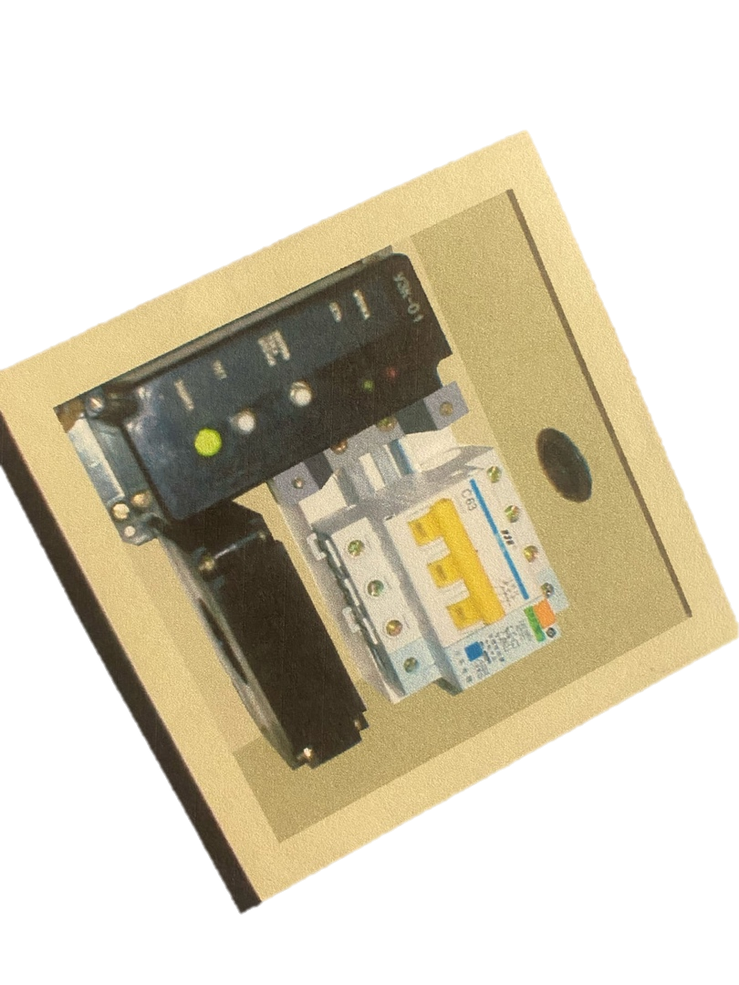

Figure 2 – Arrangement of component parts of the RCD

UZK-01 has the following advantages compared to its rivals:

- Increased value of the rated current - 125 A with the prospect of its further increase to 250A (for existing analogues - 63A), which expands the scope and allows installing devices at the input of electrical installations of a production facility.
- Multistage discretely adjustable setting of operation, which allows the device to be adapted to a real electrical network.
- Presence of a pre-emergency mode alarm, which increases the reliability of the facility's power supply.
- The ability to monitor the state of the insulation of the protected network, which increases the level of operation of electrical installations.
- Overvoltage protection capability.
Thus, UZK-01 is a universal residual current device with a wide range of applications, superior in functionality to well-known foreign analogues. During the tests at the Altai Geophysical Plant, the products were found to meet the specifications of ILKYu 425.328.001 TU in their parameters.
Testing schedule included measurement of the following parameters:
– the value of the rated breaking differential current I_{n} set by the setting switch;
– the value of the rated non-breaking differential current in accordance with the set position of the switch of the protection operation settings;
– operation of the differential current detection alarm in accordance with the set position of the protection operation settings switch;
– operation of the differential current detection alarm according to the set position of the setup tripping switch in the leakage current monitoring mode;
– protection operation time for all setups at operating voltage and presence of the residual current of 2I_{n};
– operation at overvoltage and overvoltage tripping operation.
Trial operation of UZK-01 products at residential and civil facilities has shown that residual current devices are effective and reliable means of electrical protection in low voltage electrical installations. To facilitate the connection of the product, the design of the unit should provide for the possibility of changing the location of the leakage current sensor - zero sequence differential current transformer (Figure 2).

2. Electronic Residual Current Device
A key component of the RCD is a leakage current sensor that is a differential current transformer (DCT). Its operation relies upon the induction of EMF in the toroidal winding, covering the conductor carrying the current measured. The current winding consists of two conductors for a single-phase network and four for a three-phase network, passing inside a toroidal core. In this case, the operating current can be dozens and hundreds of amperes, therefore the current conductor must have a sufficiently large cross-section, which does not allow the primary winding to be made of several turns. The measuring (secondary) winding is wound with an insulated wire so that the insulation between the first and last turns, as well as between the terminals, must withstand voltages up to 1000 V.
In order to implement the principle of constructing noise-immune protective shutdown circuits, which, at significant rated load currents (up to 125 A), react to very small current leakages not exceeding 6 or 30 mA, it is necessary to develop a sensor (DCT) with the following properties:
- The material for the magnetic circuit must have low values of coercive force and high magnetic permeability, as well as have a minimum residual induction to ensure the stability of the sensor parameters (DCT) after exposure to overcurrents. Magnetic materials for a DCT magnetic circuit operating in an alternating magnetic field must have a narrow hysteresis cycle and a large slope of the V (H) characteristic in weak fields.
- The design of the DCT should provide noise immunity under the influence of EMF unbalance and other destabilizing factors, the protection operation setting should not go beyond the specified limits.
- The inductance of the measuring winding together with the input capacitance of the device must provide resonance at the frequency of the supply network and have sufficient resistance to limit the current that occurs when the device is disconnected in the event of a short circuit in the network.
The developed and manufactured DCT sample with the GAMMAMET alloy core meets all the above requirements and provides an output voltage of 0.008; 0.026 and 0.25 V at leakage currents of 0.006, 0.01, 0.03 and 0.3 A, respectively. The transformer allows operation and retains its parameters after exposure to overcurrents up to 1500 A, while the error does not exceed two percent.
The reasons for the emergence of EMF imbalance in a differential current transformer are currently quite fully investigated. The main ones are the imperfection of the geometric design of the DCT and the asymmetric arrangement of current-carrying conductors in relation to the magnetic circuit. The EMF imbalance value depends on the load current, the ratio of the external and internal radii and the magnetic permeability of the toroidal core, the degree of displacement of the current-carrying conductors relative to the geometric center of the magnetic circuit. The most effective methods of EMF imbalance reduction are use of materials with high magnetic permeability for the magnetic circuit; the use of toroidal cores with the greatest possible multiplicity of dimensions of the outer and inner diameters; reduction of the cross-section of the secondary winding conductors; shielding the core with screens made of soft magnetic materials. Meeting these requirements allows at the same time to significantly reduce the influence of external magnetic fields. The filters of the higher harmonics of the response delay system in the DCT signal converter allow to avoid false RCD trips as a result of the influence of higher harmonics of the load current, as well as currents induced by high-voltage lines and lightning discharges.
The above methods of EMF imbalance reduction and increase noise immunity against false operation can be used in the RCDs with electronic amplifiers. The DCT here plays an extra role of a voltage transformer connected to the electronic amplifier with a high input resistance. The design of such DCT should provide for a large number of secondary winding turns to get a required useful signal. However, one should bear in mind that the increase in the number of turns results in the increase in the RCD sensitivity to the interference.
The studies have shown that the differential current transformers meet the following requirements:
– magnetic core material has minimum residual induction;
– the minimum value of the magnetic permeability corresponds to the intensity of the magnetic field created by a current of not more than 0.01 A;
– the inductance of the secondary winding of the transformer lies within 0.5 - 4 Hz, and the capacitance of the capacitor connected at the input of the device is 2 - 20 mcF, thereby limiting the current in the winding to 2.5 A and a resonant frequency of 50 Hz;
– the primary winding wire can withstand a current of up to 1500 A, has a mechanical fastening that prevents the insulation from moving, and has a dielectric strength of up to 1500 V;
– the wire of the secondary winding of the transformer is capable of passing a current of up to 2.5 A for a long time, and the insulation between the terminals of the winding can withstand voltage up to 500 V;
– the design of the transformer provides an additional winding in the secondary circuit (≈10 turns) to carry out the function of monitoring the insulation of the electrical network.
The use of such a DCT design made it possible to create electronic RCDs operating at rated load currents up to 125 A and a rated breaking differential current up to 30 mA.

3. A Hybrid Electromechanical RCD
One of the promising directions in the development of residual current devices in Russia is the creation of electromechanical devices that have a number of advantages over electronic ones. However, domestic production of RCDs is limited to electronic products and semi-finished products assembled from foreign components (Austria, China). The reason for this is the lack of technology for creating high-precision polarized relays with a kinematic amplifier to control the RCD switching unit.
The solution to the issue of creating electromechanical RCDs is possible with the participation of an enterprise that manufactures circuit breakers and makes their revision in order to be used as an RCD switching unit. In this case, the implementation of various options is possible determined not only based on the optimal layout, but also on the parameters of the electromechanical converter, as well as the sensor - differential current transformer. Depending on the option of choice, various methods of compensation for the unbalance current should be used as well as stabilization of characteristics caused by the possibility of magnetizing the magnetic circuit of the DCT by short-circuit currents, detuning from the influence of the three-fold external magnetic interference and higher harmonics leading to false alarms, etc.
Thus, the key tasks of the investigation in creation of a new RCD type are:
– development of an electromechanical converter and differential current transformer;
– development of a manufacturing procedure for a hybrid RCD comprising a magnetic and electric relay (instead of an electronic and kinematic amplifier) and a triac controlling a shunt release of an automatic circuit breaker connected with the sensing unit of the RCD.
These tasks have been solved during preparation of RCD manufacture at the Divnogorsk plant of low-voltage equipment (Krasnoyarsk Territory).
Study of the Electromechanical Converter. Abroad [8], the most common design options for electromechanical converters are bipolar and unipolar circuits (Figure 3). In both systems, the movable anchor is held in its original state by a permanent magnet, which, among other things, overcomes the resistance of the opposing spring. The current flowing through the yoke changes or weakens the constant magnetic field. In this case, the anchor is detached from the magnetic circuit under the action of the spring and, by means of a pusher, acts on the opening mechanism of the circuit breaker.

Bipolar circuit | Unipolar system

Figure 3 – Options of electromechanical transducer with holding magnet

The difference between the options lies in the fact that in the bipolar circuit, the off state is provided for any direction of the current, and in the unipolar circuit, only for one direction, corresponding to the weakening of the permanent magnet field.
In the proposed relay design, a bipolar circuit is used, shown in Figure 4. The action of such a relay is based on the interaction of the magnetic field of permanent magnet 5 and an alternating current (50 Hz) in winding 4, located on anchor 3. Rocker arm 6 and the armature act as a magnetic flux conductor, created by a permanent magnet, which ensures the attraction of the rocker arm to the anchor. By turning the permanent magnet around its axis, it is possible to change the tangential component of the magnetic flux flowing through the magnetic circuit, and, thereby, to regulate the force of attraction of the rocker arm to the armature, setting the required relay sensitivity, which determines the response setting. When a leakage signal arrives at the relay coil from the output of the differential current transformer, the armature is demagnetized, the rocker arm, under the action of spring 7, leans back and through pusher 2 closes the normally open contacts of the relay. The function of the kinematic amplifier is performed by a triac that controls the shunt release of the circuit breaker and is included in a separate unit of the hybrid residual current device.

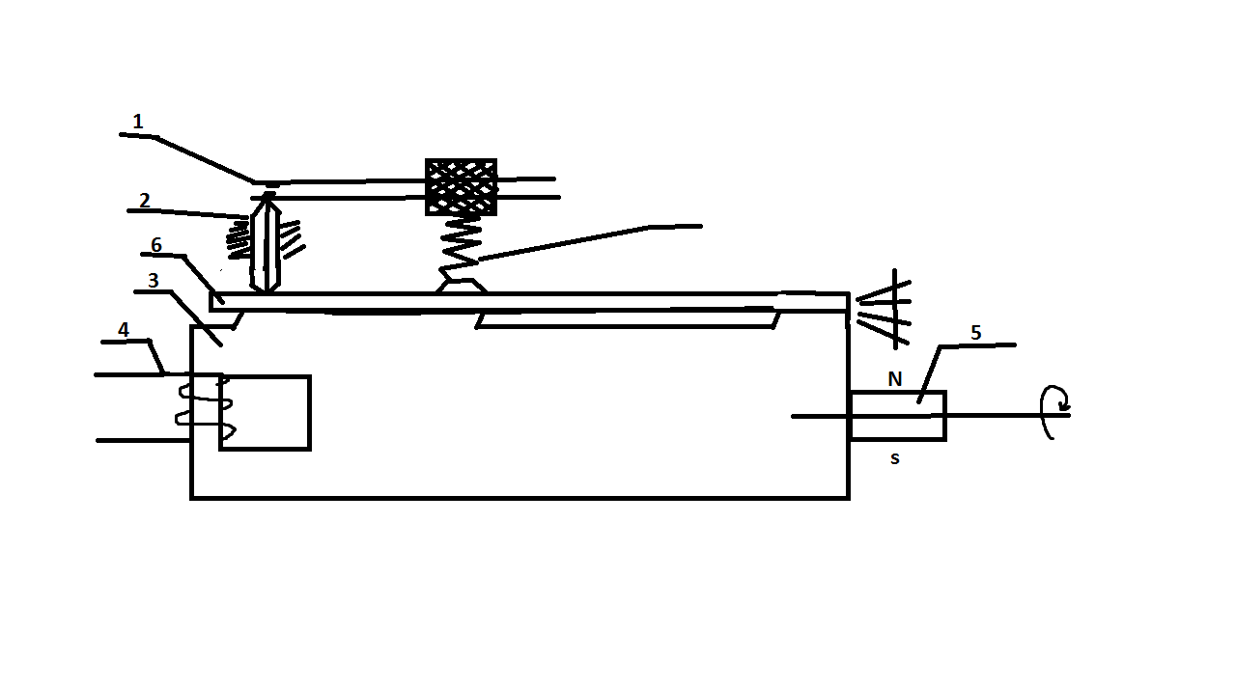
7
S
Figure 4 – Magneto electric relay design

Considering that the main structural elements of a magnetic relay are a permanent magnet, a magnetic circuit and a spring, which determine the sensitivity and reliability of the RCD, we carried out research on the selection of raw materials and the development of technology for the manufacture of parts and their assembly. The main requirements for the material of the magnetic circuit are high magnetic permeability and a narrow hysteresis loop, taking into account operation in weak magnetic fields (0.5-2 A/m). The studies carried out have shown the possibility of using permalloy type 79NM (GOST 101160-75) for the magnetic circuit.
The spring of the magnetic relay is the most important structural element and must meet the requirements to ensure the stability of its dynamometric characteristics over time. Failure to comply with these requirements may lead to a change in the RCD trip setting during operation, which is unacceptable. Therefore, the use of silicon-vanadium steels with a high modulus of elasticity has been proposed as a spring material. The tests also showed the possibility of using steels with a lower elasticity, in particular, a wire spring made of 65G steel (GOST 9384-80), provided that the wire from which the spring is wound is used horizontally and in the direction opposite to the winding.
Study of the Differential Current Transformer. In residual current devices with an electromechanical converter, the DCT is used as a current transformer connected to a load with a low input resistance. Since the number of turns of the secondary winding of the DCT in this case is very small (from several turns - up to several dozens), the sensitivity to the influence of interference sources is significantly reduced. Therefore, the practical implementation of measures to prevent false alarms of such RCDs is greatly simplified. One of the issues of stabilizing the characteristics of the RCD is the elimination of residual magnetization of the DCT core by single-phase short-circuit currents, leading to a change in the sensitivity and unstable operation of the protection. The reason for the change in sensitivity is the change in the slope of the hysteresis loop of the DCT core after magnetization of the short-circuit current [9].
An effective way to stabilize the characteristics is by connecting a pre-charged capacitor in parallel with the secondary winding of the DCT after each operation of the RCD. At the same time, an auxiliary oscillatory process occurs in the LC-circuit formed by a capacitor with a DCT winding, which ensures demagnetization of the DCT along an anhysteresis-free curve, that is, the establishment of its operating point in the initial section of the magnetization curve. The nominal value of the capacitance of the capacitor is chosen so that the resonant frequency of the LC-circuit is higher than the industrial frequency of the protected network. This is necessary to eliminate the influence of resonance at the power frequency during the operation of the residual current device.
Taking into account the results of the research carried out, a residual current device has been developed, the structural, schematic diagrams and general view of which are shown in Figures 5, 6 and 7.
The device contains differential current transformer 1, to the output of which electromechanical converter 2 is connected linked to switching unit 3 containing an electromechanical contact 4 connected in series with current-limiting resistors 5 and 6 and having the ability to control semiconductor switch 7 based on a triac; switching unit 3 connected to actuator 8. The actuator is a circuit breaker with a shunt release, which trips when voltage is applied to the release coil from an external power source.

Supply 220 VAC

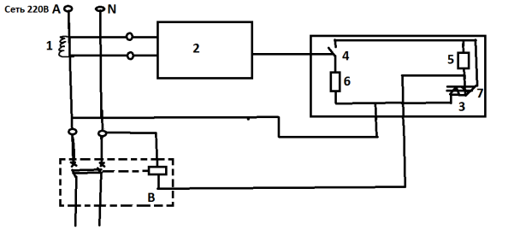
To load

Figure 5 – Structural diagram of RCD-ЭЛНИС

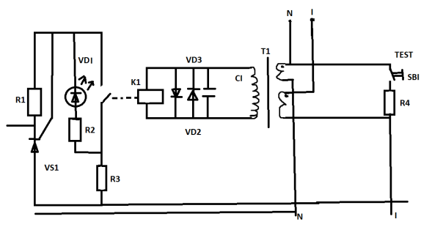

Figure 6 – Electric wiring diagram of RCD-ЭЛНИС

Figure 7 – General view of residual current device
RCD-ЭЛНИС (mockup specimen)

Industrial Use of a Hybrid RCD with an Electromechanical Converter. The successful test results of the developed RCD made it possible to launch the production of the first hybrid RCDs, combining an electronic amplifier based on a semiconductor switch with an electromechanical converter from domestic components. The RCD is produced on the basis of the VA 61-29 circuit breaker (Figure 7).
The product is a single-phase two-wire stationary autonomous residual current device with built-in overcurrent protection controlled by differential current with a fixed magnitude of the operating current, operating in alternating current power grids with a frequency of 50 Hz with a rated voltage of 220 V and a load current of up to 63 A. The RCD is characterized by increased reliability. The calculated MTBF of the product is more than 30 years, which is 3-4 times higher than that of an electronic RCD. The volume of production since the beginning of production has amounted to more than 50,000 units. [10]

Literature

- Abdullah M. Z., Ariffin R. Power quality analysis of Residual Current Device [RCD] nuisance tripping at commercial buildings //2013 IEEE Symposium on Industrial Electronics & Applications. – IEEE, 2013. – С. 122-125.
- Czapp S. Protection against electric shock using residual current devices in circuits with electronic equipment //Elektronika ir Elektrotechnika. – 2007. – Т. 76. – №. 4. – С. 51-54.
- Shopov Y., Filipova-Petrakieva S., Boychev B. Investigation of residual current devices in high frequencies //2018 10th Electrical Engineering Faculty Conference (BulEF). – IEEE, 2018. – С. 1-3.
- R.N. Karyakin, Standards for the construction of safe electrical installations. - М.:Energoservis,2000.-453 p.
- Parise G., Annibaldi S., Martirano L. Toward alignment of safety levels concerning electrical installations in the EU //IEEE Industry Applications Magazine. – 2001. – Т. 7. – №. 3. – С. 73-82.
- Biegelmeier G. Kannder Fehlerstromschutzschalter die Technik des Beruhrungsspannungsschutzes revolutionieren? “Electrotechnik und Maschinendan”, 1954.№4.
- Rotter K. Elektrosehuts- Felten Guibleaume. Fabrik Elektriseher Apparate Aktiengesellschaft, 1990.
- TEC Standart 364-4-41/Electrial installations of buildings. Part 4: Protection for safety.Chapter 41:Proctionagainst electric shoks.1992 – 10.
- Stanbury M., Djekic Z. The impact of current-transformer saturation on transformer differential protection //IEEE Transactions on Power Delivery. – 2014. – Т. 30. – №. 3. – С. 1278-1287.
- А.I. Logvinov, A.P. Rodin, Experience of batch production of residual current devices in Russia // Newsletter of Polzunov AltSTU - Barnaul, 2000. No.3.

